Tony Crawley,
Chief Executive,
PSAA Limited,
18 Smith Square
London
SW1P 3HZ

18 June 2019

Dear Mr Crawley,

I am writing to you on behalf of the Resources Board of the LGA to raise concerns about the impact of the decision by Ernst and Young to delay the audit of accounts for local authorities covered by it in the East of England / East Midlands. We understand that Ernst and Young say this is due to an unavoidable shortage of suitably qualified senior auditors which has arisen in this part of the country.

Ernst and Young’s decision means the local authorities affected won’t be able to publish their accounts by the 31 July deadline with an audit certificate, as would normally be expected for the 2018/19 accounts. This affects sixteen councils, as well the two Police and Crime commissioners and the single Combined Fire Authority.

Clearly this is not a satisfactory position and all those affected would like steps to be taken to avoid this situation. However, given the timing, it is likely that the only practical step to avoid the situation would be for Ernst and Young to reverse the action they have said they will take. Since that is unlikely, it is important that the problems of those local authorities affected are minimised and that they do not suffer additional consequences for something which is clearly out of their control. Councils should not be criticised for failing meeting a deadline through no fault of their own.

For example, the LGA’s Resources Board thought that the affected local authorities should be excluded from any reporting of performance metrics where the failure of their accounts being audited would show them in a bad light, for example reporting of councils that have / have not published their accounts on time.

The Resources Board was also concerned that the affected councils do not incur additional costs, particularly audit costs, as a result. .We would ask that PSAA ensure through the contract management process that this does not happen

Clearly the delay will cause councils great inconvenience. Reporting timetables will have to be changed. Council staff will have to spend time on the accounts when they would be planned to be working on other matters – such as planning the budget for the next year; critical staff will have booked leave over the summer in the expectation that the accounts process will be complete by the 31st July. This may mean key staff won’t be available at crucial times for the audit, or for additional staff resources needing to be employed; they may also have to spend longer on working on the accounts and providing the auditors with support and information. In such circumstances, it would clearly be unfair for councils to incur any additional audit costs.

We understand PSAA are continuing to discuss with Ernst and Young and the authorities affected and we hope that all steps can be taken to ensure the audits take place as soon as possible. We are grateful to PSAA for keeping us sighted on the issue and for liaising in relation to the response.

Yours faithfully

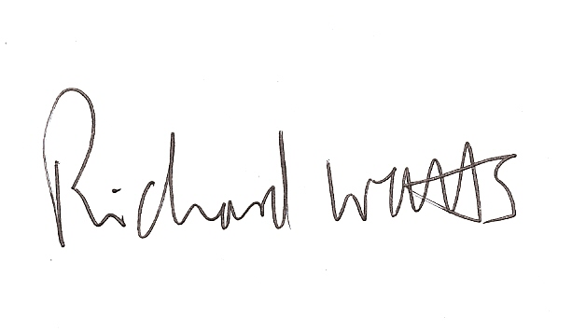

Cllr Richard Watts,
Chair Resources Board

